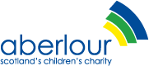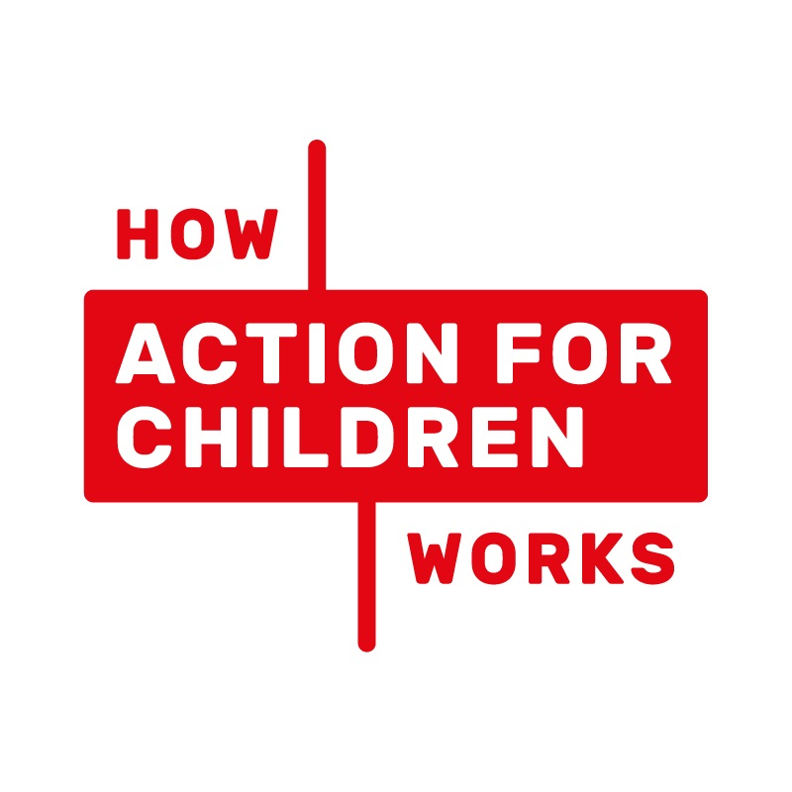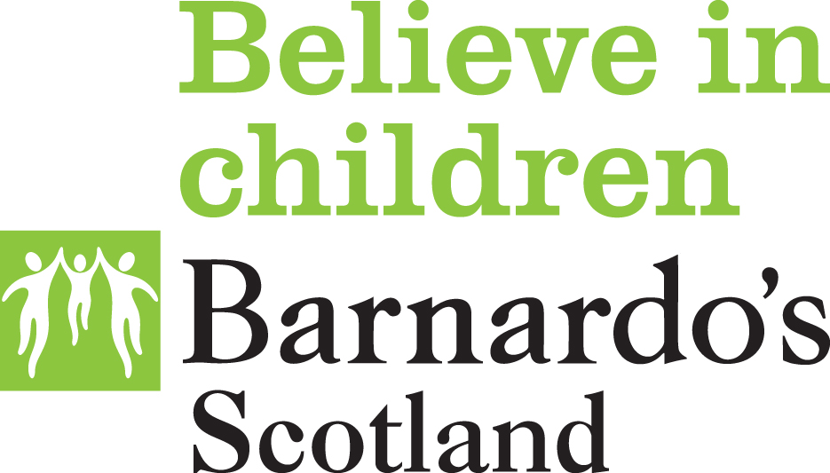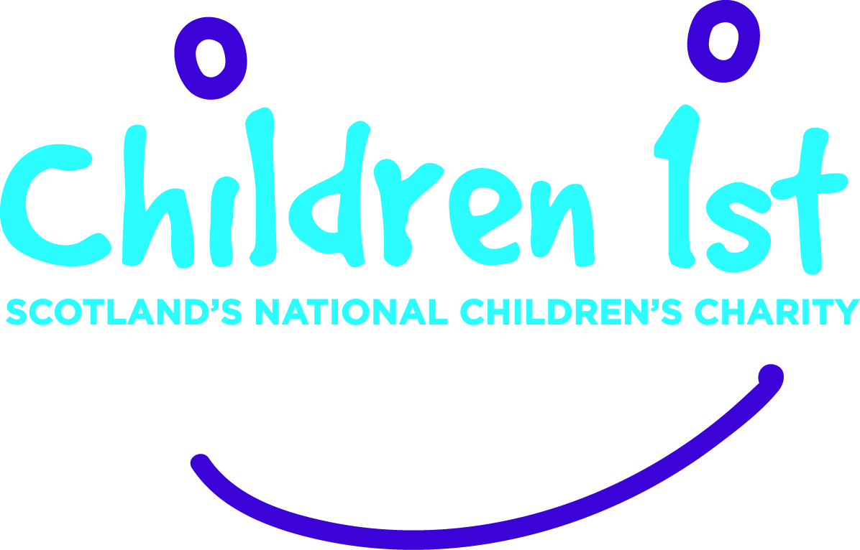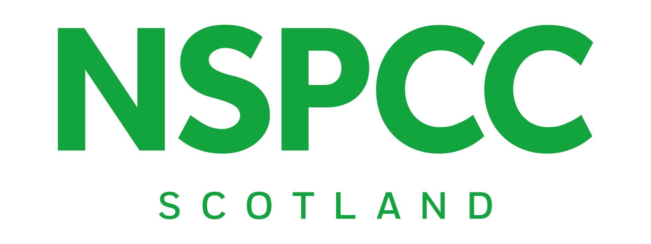
Joint response to the call for Evidence from the Education & Skills Committee on the Children and Young People (Information Sharing) (Scotland) Bill
We respond to this consultation as a group of service providers that work alongside children and families to provide support when they need it. Our organisations have been supportive of the aims and objectives of the Children and Young People (Scotland) Act 2014 since that Bill was first introduced.
We continue to support the principle of the Named Person. Our support is rooted in our experience of working with children and families and the hope that the Named Person service, if fully resourced and consistently implemented, would help children and support families, serving as a useful point of contact for families to access advice and services.
The comments below relate specifically to the provisions contained in the Children and Young People (Information Sharing) (Scotland) Bill, and are not intended to be read as commentary on the wider policy objectives of the 2014 Act.
To varying degrees, we have all had some involvement in working with the Scottish Government on related legislation and guidance to date. Our evidence below is consistent with comments we have made throughout the development of the 2014 Act, the guidance to accompany that Act, and the current Bill.
Lastly, we endorse and support the briefing that has been provided by Together, the Scottish Alliance for Children’s Rights, as members of that organisation. We would encourage Members to read this response alongside that comprehensive briefing.
Key issues
- We remain supportive of the principle of the Named Person.
- Clear and consistent communication, both with practitioners and with children and families, will be key to the success of the Named Person service.
- While the issues highlighted by the Supreme Court judgment must be addressed, the primary purpose of the current Bill must be to support families and underpin the effective operation of the Named Person service.
- It is not clear how the current Bill and the accompanying code of practice develop the law around information sharing and data protection, particularly in light of the forthcoming introduction of the General Data Protection Regulation (GDPR).
- The current illustrative Code of Practice is overly legal and complex.
- We have called previously for practice guidance which covers Parts 4, 5 and 18 of the 2014 Act in their entirety; this may provide more context and clarity rather than focussing specifically on information sharing in the code of practice.
- All materials related to the Named Person service and information sharing must provide clarity to professionals, but fail to do so in this current form.
- Simple and accessible training and educational awareness materials should be developed which would make it easier for children, families, and practitioners to understand the various complexities and give proper implementation to the code, Bill, and named person service.
Clear and consistent communication about the Named Person service
We recognise that this call for evidence is specifically about the Children and Young People (Information Sharing) (Scotland) Bill and we do not expect the Bill to legislate for how its contents are communicated. However, there will inevitably be public and media interest in the Bill as it progresses and we consider it vital that the Scottish Government develops a strategy about how to communicate clearly how the Named Person service will operate in light of any proposed changes.
Named Person has generated much public debate, and children and families remain unclear about what the Named Person is and how it will operate. Through the passage of this Bill and beyond, the Scottish Government must communicate with families and the wider public in a way which is clear, consistent and accessible.
In addition to the need for clear communication with children and families, we also highlight to the Committee the importance of clear communication with professionals and service providers. Following the Supreme Court judgment and the introduction of the current Bill, there is increasing confusion about, and differentiation in practice in, what professionals are expected to deliver and how information should be shared. Anecdotally, we have heard that professionals in some areas are ever more cautious about information sharing because of concerns about falling foul of the law.
As the Bill and Code of Practice progress through their respective processes, we seek clarity on how the Scottish Government will help children and families to understand clearly what the Named Person service is and how it will work; and also help professionals to understand clearly what is expected of them in terms of operating the Named Person service or sharing information within it.
This is why it is imperative for the development of training and educational awareness materials, which are easy to understand and made widely accessible to all. This will help all those who this service and legislation aims to help - children, families and practitioners – to better understand the complex issues and their obligations in order to ensure the effective implementation of the code, bill and named person service
Children and Young People (Information Sharing) (Scotland) Bill
We are clear that, while the judgment from the Supreme Court is a significant part of the context for the Bill, the task at hand is not exclusively about addressing that judgment, though of course that must be done.
For us, the focus must be about making the Named Person service operationally effective in a way that helps families to understand the legislation and embeds a rights-based, child-centred, family-minded approach at the centre of practice where, ultimately, more children and families are supported. We would encourage Members to consider evidence on the Bill in this way, focusing on how the present Bill can best aid the delivery of the policy objectives of the 2014 Act, rather than purely address the judgment.
From our reading, in addition to repealing sections from the 2014 Act, the Bill appears to restate the current legal position: that all information must be shared in accordance with the Data Protection Act 1998, and any other relevant legislation. As such, we are unclear how the current Bill develops the existing legal landscape.
Furthermore, the current law on data protection will itself change significantly next year with the introduction of the General Data Protection Regulation (GDPR). As we understand it, GDPR introduces a number of changes to the Data Protection Act 1998, particularly in terms of consent , for example that consent must be a clear and affirmative act.
While the Bill includes reference to ‘any directly applicable EU instrument’, and the illustrative Code of Practice makes fleeting reference to GDPR, we do not feel sufficient consideration has been given to the implications of GDPR. We are keen to get assurances from the Scottish Government that information sharing under the Bill has fully taken account of these imminent provisions and that its requirements are clearly articulated on the face of the Bill, as necessary, and certainly explored in detail in the Code of Practice and relevant guidance.
Code of Practice on information sharing under Part 4 and 5 of the Children and Young People (Scotland) Act 2014
We recognise the need for a statutory Code of Practice, as outlined in the Bill. However, it is our view that the success or otherwise of the Named Person Service and effective information sharing cannot be dependent on the Code of Practice as it currently stands, as it does not provide the necessary clarity for those professionals who will be putting it into practice on a day to day basis.
Although the stated audience at the beginning of the draft Code of Practice is “persons exercising functions under Parts 4, 5 and 18 of the Act and who may provide information when exercising these functions”, we are concerned that the legalistic language and terminology in the current draft is inaccessible to the people who would find it most useful. We would also encourage the Code of Practice to be drafted in a rights-based way that returns to the principle behind the Named Person service—supporting children and families—and puts the child at the centre.
We recognise the Code of Practice is currently an ‘indicative draft’. However it is impossible to detach the Bill from the Code of Practice and therefore it is difficult not to look at the Bill through the prism of the Code of Practice.
To simplify this process for all those involved, we would call for a clear and concise statement about what guidance will be provided alongside the Code of Practice. In particular this should make reference to how this particular Bill ties in with the other provisions of the Children and Young People Act, focusing on the wider aspects of the Named Person service. This statement should outline estimated timescales for publication, what opportunities there will be for consultation and input, and clearly outline the relationship between all the parts of this legislation.
Our organisations have consistently called for robust and comprehensive statutory national practice guidance that covers all of Parts 4, 5 and 18 of the Act, including clearly outlining the functions of the Named Person service and how it will operate in practice. We repeat this call here. We understand the policy intention behind a broad definition of wellbeing, and the opportunity that this provides for practitioners to use their professional judgement in relation to what constitutes a concern in particular circumstances. However, we would welcome much more information within practice guidance on how the Named Person service will operate in practice, including the way in which professionals will identify and share wellbeing concerns. As service providers we have identified complexities about how the third sector will engage with the Named Person service and we would welcome exploration of some of these issues within the accompanying materials.
We understand from the Scottish Government that they are currently considering how the draft statutory guidance can contain or be supplemented by national practice guidance, or materials, for Parts 4, 5 and 18 and would welcome the Committee to explore further how this could help to provide clarity to professionals, children and families. We believe that practice guidance would provide context for the requirements on practitioners around information sharing, which is lacking in the current Code of Practice. We also note that there will be a need to produce information which is accessible to children, young people and families, which clearly outlines information sharing and the named person service in an easy to understand way.
Given the aforementioned need for clarity, we have significant reservations about how navigable a complicated suite of supporting materials will be for professionals. The Government must therefore be clear during the passage of this Bill about the guidance or practice materials they intend to make available to give confidence to those working in this area. Clarity would also be welcome on the legislative status of the Code of Practice and the opportunity for consultation and amendment during its Parliamentary journey. We would suggest drafts of such materials may be helpful for the Committee to review in its scrutiny of this legislation. Without clarity, we are concerned that there is a danger of an inconsistent approach being adopted across local authorities, health boards and other organisations, with different interpretations and understandings being defined by different organisations.
Until these issues are resolved and the legislation, Code of Practice and accompanying materials provide the necessary clarity across the country, service providers will not always be able to deliver the function of the Named Person effectively.

Sally Ann Kelly, Chief Executive, Aberlour
Paul Carberry, Director, Action for Children Scotland
Martin Crewe, Director, Barnardo’s Scotland
Mary Glasgow, Acting Chief Executive, Children 1st
Angela Morgan, Chief Executive, Includem
Matt Forde, National Head of Service, NSPCC Scotland
Clare Simpson, PAS Manager, Parenting Across Scotland

August 2017

The Christian Institute and others v Lord Advocate (Scotland) [2016] UKSC 51

